MARMARA UNIVERSITY
FACULTY OF ENGINEERING
COMPUTER ENGINEERING

PHYS1103
PHYSICS LABORATORY
EXPERIMENT 6
Finding Static Friction Coefficient
SXGXE6

NAME | STUDENT NUMBER

Submitted to: Hüseyin YALTIRIK

Experiment Date: 26.11.2019 Due Date: 02.12.2019
1-) PURPOSE
Find the static friction coefficients of an object which is moving because of gravity.
2-) THEORY
The net force is the sum of the all the forces acting on an object. We know from Newton’s second law, if there is a net force there will be acceleration too.
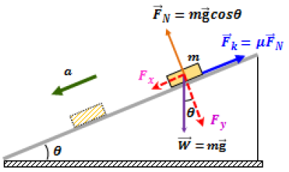
Figure 1 The movement of an object on the inclined table
In this figure there is an object moving with effect of gravitational force and it is on an inclined table with a slope. Like we saw the force has two components.
$$F_{x}=mgsinƟ -x component$$
$$F_{y}=mgcosƟ -y component$$
The y component of force defines the magnitude of the frictional force owing to the normal force to the mass
$$F_{k}={µF}_{N}$$

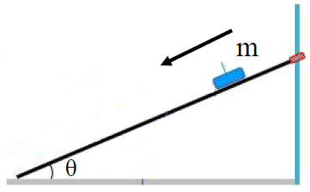
Figure 2 The experimental setup

We will find the statically friction coefficient between the surface and object by experiment. For this we will look examine the object by the position on the inclined table.

If the net force on the force is zero, there is a relation between the critical angle and statically friction coefficient when the object starts to move.

$$F_{x}=F_{k}$$

$$mgsinƟ= µF_{N}$$

$$mgsinƟ= µmgcosƟ$$

$$sinƟ=µcosƟ$$

$$µ= \frac{sinƟ}{cosƟ}$$
$$µ=tanƟ$$

3-) EXPERIMENTAL SETUP
The materials that have been used in this experiment are:

- Inclined table
- A cube with 4 surfaces made from different matter
- Pen and paper

The object is released from the top of the inclined table four times, every time with different surface. We will examine in which value of slope of inclined table the object will start to move. We will make these three times and we will get the average of the slope for a value righter.

4-) CALCULATIONS & RESULTS
Table 1 Static friction coefficient
Surface | Mass (g) |  | Ɵ₁(degree) | Ɵ₂(degree) | Ɵ₃(degree) | Ɵ_{avg} (degree) | µ
S1: Kraft Paper | 1 | 300 | 30 | 29 | 28 | 29 | 0.554
S1: Kraft Paper | 2 | 575 | 30 | 29 | 32 | 30.33 | 0.585
S2: Rubber | 3 | 300 | 33 | 30 | 29 | 30.66 | 0.593
S2: Rubber | 4 | 575 | 33 | 31 | 29 | 31 | 0.600
S3: Sandpaper | 5 | 300 | 27 | 28 | 31 | 28.66 | 0.547
S3: Sandpaper | 6 | 575 | 29 | 30 | 28 | 29 | 0.554
S4: Fiberboard | 7 | 300 | 15 | 15 | 16 | 15.33 | 0.274
S4: Fiberboard | 8 | 575 | 15 | 12 | 17 | 14.66 | 0.262

Graph 1 The bar graph of statically friction coefficients vs masses and surfaces.

5-) REFERENCES
- Rentech Laboratory Manual and Workbook, Ankara, 2015

6-) APPENDIX
